RBI IT Framework Compliance for Log360
Automate RBI IT Framework compliance and fortify cybersecurity resilience for financial institutions with Log360.
Region: India | Type: Financial Services, Operational Resilience | Category: Compliance | Pricing: Free

Overview
The RBI IT Framework compliance extension in Log360 helps organizations meet RBI IT Framework for Banks, the master direction on IT governance, risk, controls, and assurance from the Reserve Bank of India effective April 2024 for scheduled commercial banks and NBFCs by providing centralized log management, SOC-ready threat detection, and compliance-grade audit trails. The platform supports RBI IT Framework requirements for IT governance, cybersecurity policy, access control, SOC threat monitoring, vulnerability assessment, IS audit, business continuity, and third-party risk management.
For IT Governance and Strategic Alignment, Log360 monitors AD logons, GPO changes, user auditing, policy events, and system logs to supply the governance evidence trail expected by RBI for IT strategic control. To address Information Security and Cyber Crisis Policy, the platform monitors policy and GPO changes, network device rule and configuration events, and registry modifications to evidence policy enforcement and security baseline maintenance. The extension also supports Access Control and Identity Management by providing capabilities that tracks AD and Windows logon and failed logon events, user account changes, Unix logon activity, and PAM usage to validate that access is granted and revoked per policy.

Key Features
- Security Operations Centre and Threat Monitoring: Log360 aggregates signals from FireEye, Trend Micro, McAfee, Windows and Unix threat detection, network attacks, and firewall events to support SOC-ready monitoring and alert triage.
- IS Audit and Continuous Monitoring: Log360 collects Windows event logs, system events, process tracking, and database audit trails to enable risk-based audit analytics and validation.
- Cyber Incident Response and Forensic Investigation: Log360 delivers real-time threat alerts and automated forensic timelines, enabling security teams to rapidly contain threats and maintain the detailed documentation required to fulfill mandatory RBI incident reporting obligations.Business
- Continuity and Disaster Recovery: Log360 monitors backup/DR policies, infrastructure status, malware detection in backup systems, job completion, and DR IAM events to validate continuity readiness.

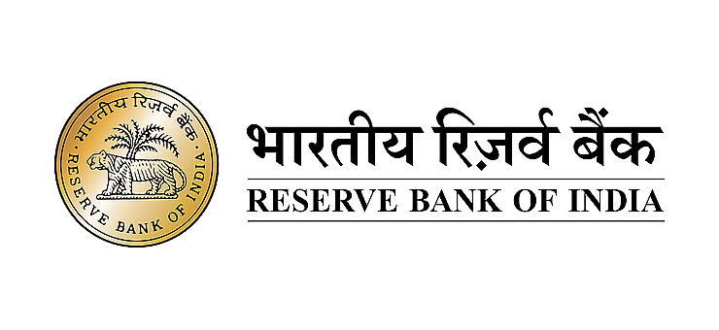
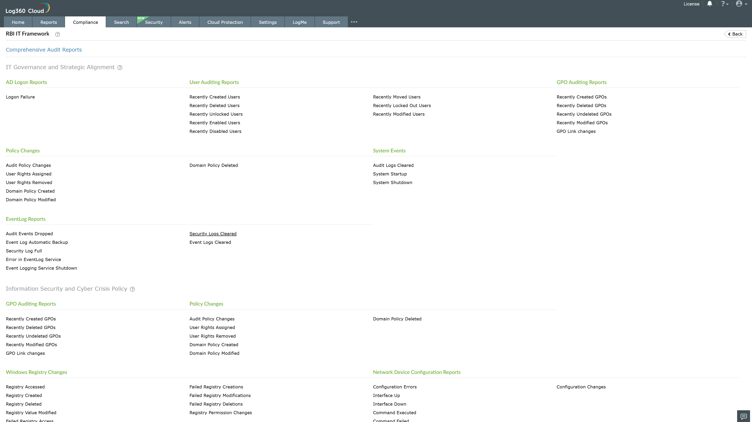
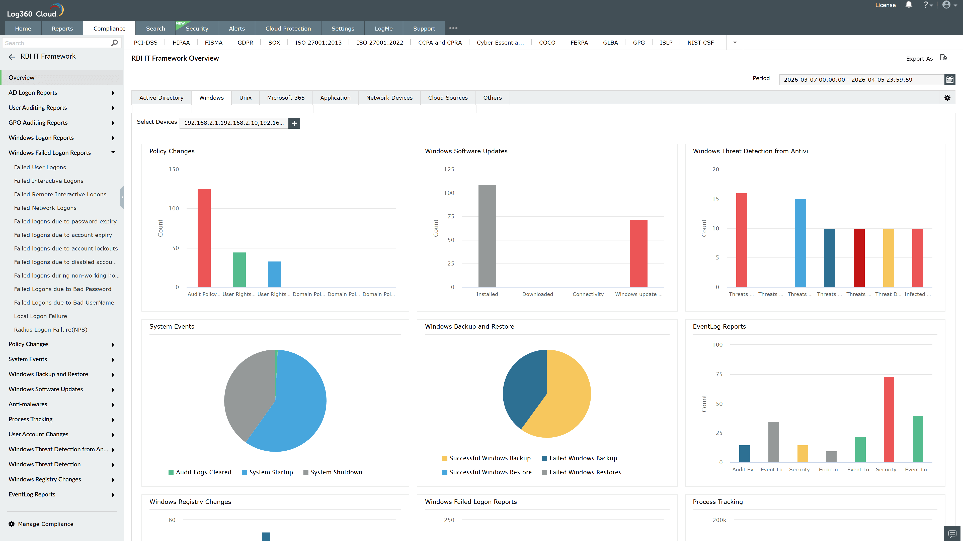
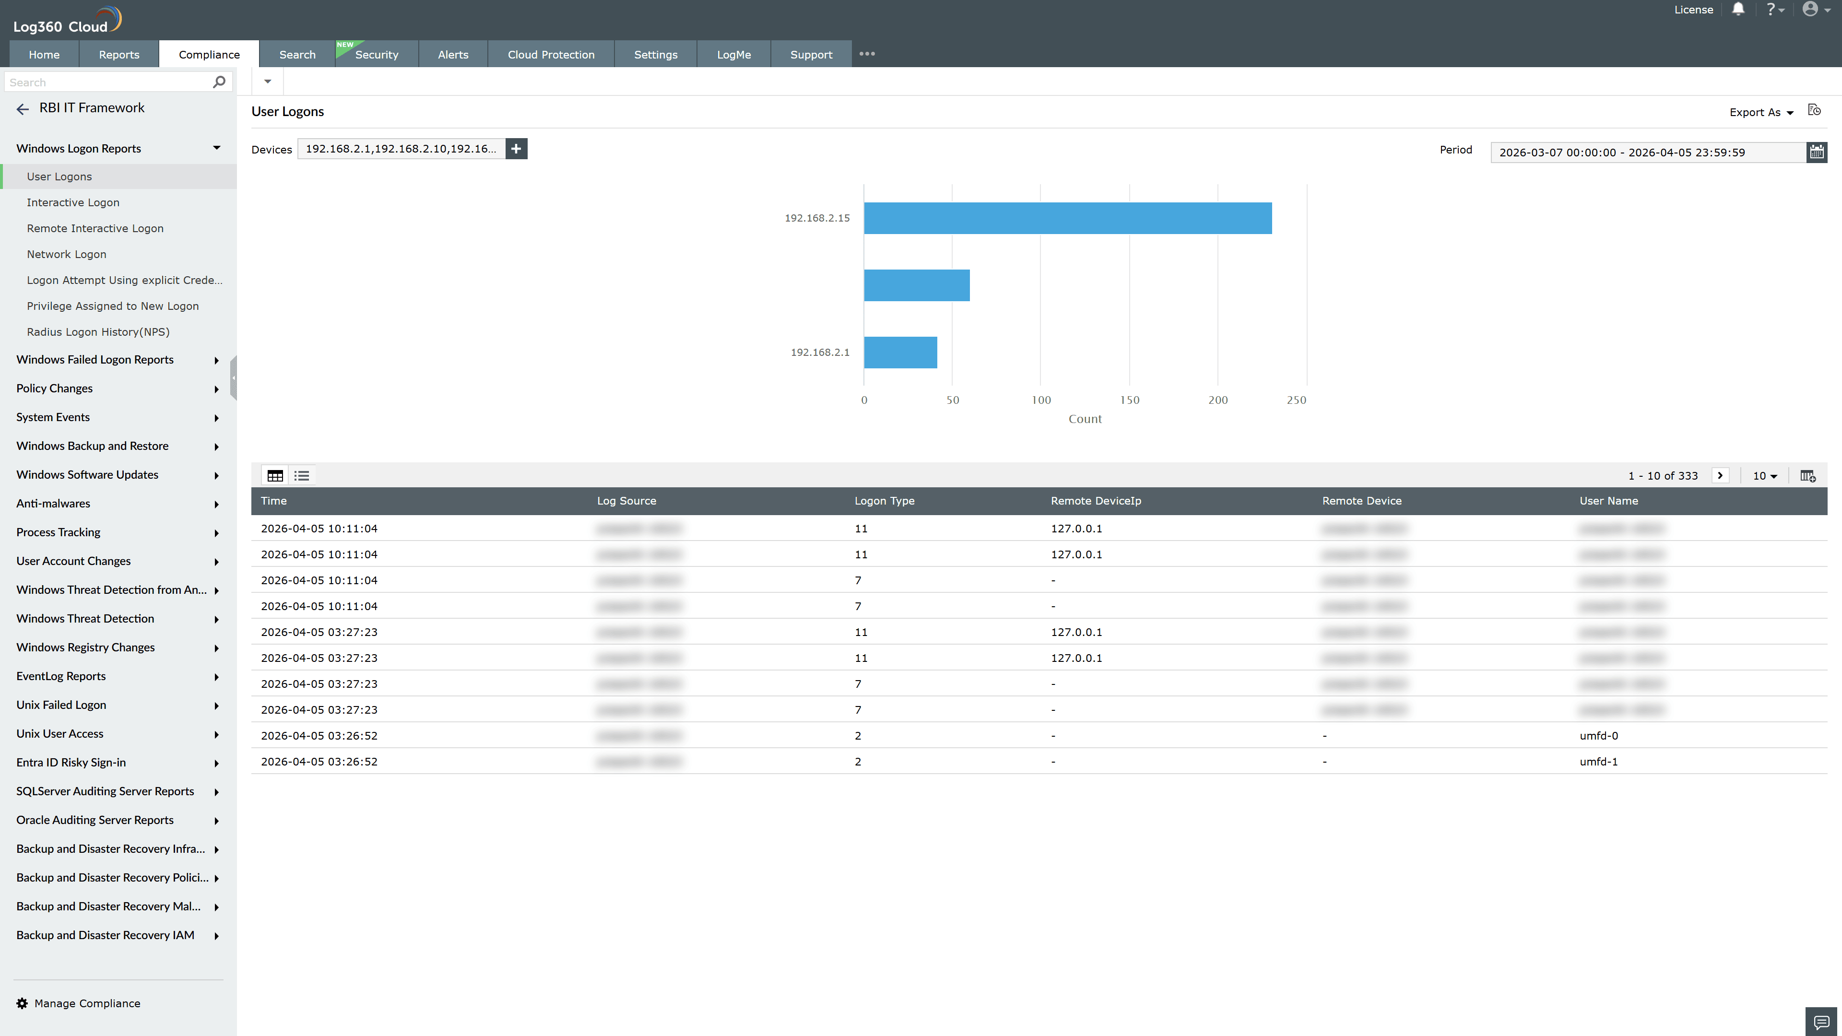
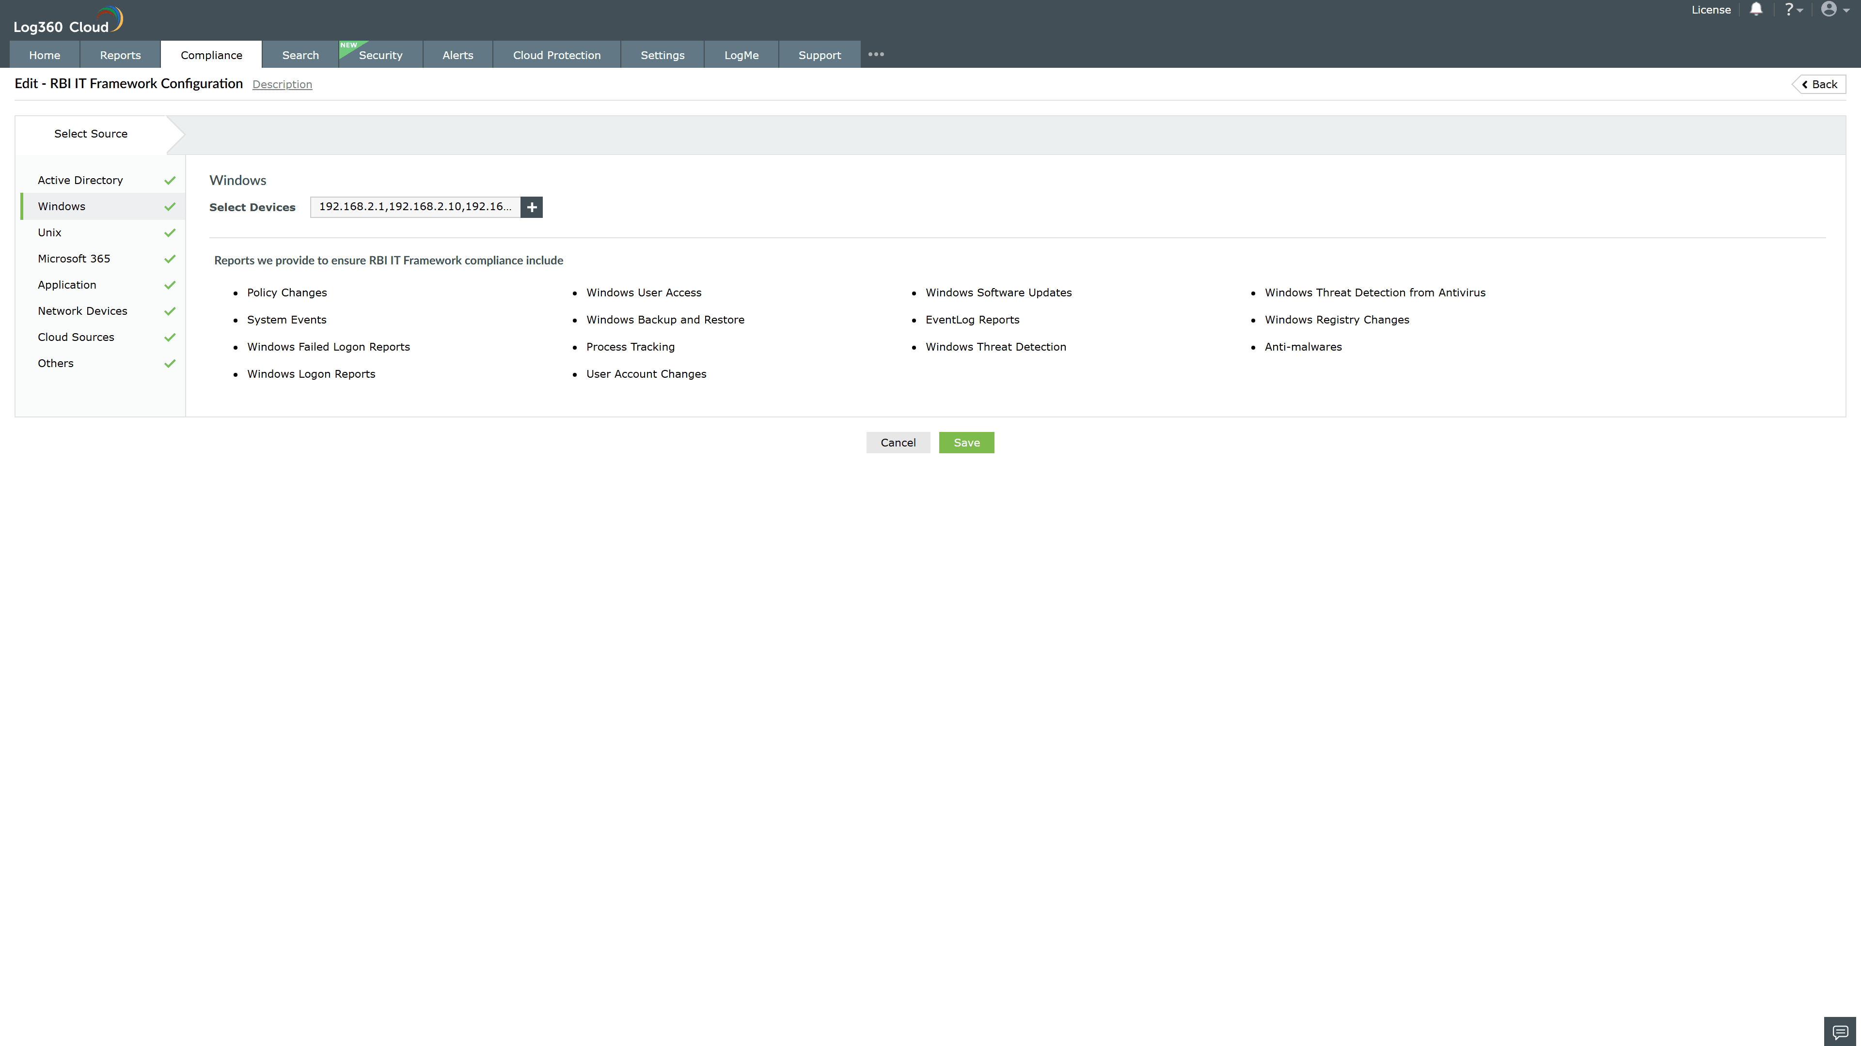
Valid Submission : Yes
Supported Editions : Free, Basic, Standard, Professional, MSSP
Help Document : https://www.manageengine.com/log-management/help/integrations/compliance-extensions.html
Help Video : Not provided
Tags : Log360, Compliance, Privacy monitoring, Data privacy, Regulatory compliance
Supported DCs : US, IN, JP, CA, AU, UK and EU
Privacy Policy:
Terms of Service:
Release Notes:
Predefined reports for the RBI IT Framework.

